


Methodology Project
Second level - Statistics Department (English Section)

Name | Code
Ahmed Hossam Mohamed | 5241121
Ahmed Mahmoud Abdelfattah | 5240136
Ahmed Adel Mesbah | 5240522
Bassant Ahmed Abdelmeeged | 5240724

Under Supervision of Dr. Sara Osama

Introduction:

As smartphones and social media become a main part of our everyday life, concerns about their impact on mental health and overall well being have increased significantly. Altough digital technology has many advantages, too much usage has been linked to higher anxiety, poor sleep, low productivity, and negative mood. As a result, many individuals have tried digital detox which is taking breaks from digital devices as a way to improve their mental health.

Despite the increasing popularity of the topic, there is still limited research on how effective digital detox is, and what factors affect its outcomes. This study aims to fill that gap by statistically examining the correlation between digital detox and well-being, anxiety, productivity, sleep quality, and mood. It also explores whether personal factors such as age, gender, and addiction level have a part in how beneficial a detox can be.

Research Objectives:

-Examine the relationship between digital detox and key personal outcomes including well being, anxiety, productivity, sleep quality, and mood.

-Explore whether demographic factors such as age and gender influence how effective a digital detox is.

-Investigate the role of smartphone addiction in heavy social media use to reduced well being and stress.

-Determine whether digital detoxing reduces anxiety more in females than in males.

Research Questions:

Q1. Well-being: Is there a significant positive correlation between the frequency of digital detoxes and enhanced well-being?

​Q2. Anxiety: Does the total duration of a digital detox negatively correlate with anxiety levels?

​Q3. Productivity: What is the direct statistical correlation between digital detox duration and daily productivity?

​Q4. Sleep Quality: Does the frequency of a digital detox significantly predict an individual's sleep quality scores?

​Q5. Mood: Does a 24-hour digital detox break significantly affect immediate mood improvement?

Q6. Age Factors: Do the correlations between digital detoxing and productivity significantly differ across age groups?

​Q7. Gender Differences: Is the effect of a digital detox on anxiety reduction significantly higher in female participants compared to male participants?

​Q8. Social Media Impact: Does smartphone addiction support the underlying relationship between heavy social media consumption and decreased well-being?

​Q9. Addiction Severity: Does a person's baseline level of addiction determine how effective a digital detox will be on their stress reduction?

​Q10. Diminishing Returns: Is there a specific threshold point where the duration of a digital detox no longer affects or increases productivity levels?

Questionnaire: https://docs.google.com/forms/d/e/1FAIpQLSexbLvVRLqyWU-xULC5n-q3D6AdgISXo3IW-jZx7GoC3PbpHw/viewform?usp=publish-editor

The questionnaire was designed to collect data with many key variables related to social media use and digital detox.

Demographics (Questions 1 & 3) Gender and age were collected to allow comparisons between groups, such as whether detox affects males and females differently, and whether outcomes change by age.

Social Media Addiction and Usage (Questions 2, 4, 5, 6, 10, 11, 12) These questions measure how heavily participants use social media and how dependent they are on it. This includes daily screen time, how often they check their phones, which platforms they find hard to quit, and whether they experience phantom vibrations which all of that can help measuring addiction severity.

Well-being & Mood (Questions 7, 8, 9, 16) These questions look at how social media usage affects participants emotionally. The FOMO scale, feelings during absence from social media, reactions to other's posts, and frequency of social comparison were all used to measure well being and mood levels.

Anxiety (Questions 13, 17) Two questions were used to measure anxiety — one asking about difficulty relaxing after social media use, and the other identifying physical anxiety symptoms when unable to access their phone.

Sleep Quality (Questions 5, 14) Sleep loss in minutes and peak usage time of day were used together to measure how social media habits especially late night use disrupt sleep.

Digital Detox (Questions 18, 19) These questions identify whether participants have attempted a detox and how it affected their stress and anxiety, which is the core measure of detox effectiveness.

Open-ended (Question 20) This question was included to gather qualitative insights that support and add depth and context to the statistical findings.

Descriptive Analysis
Gender Distribution(Bar Chart)
This bar chart illustrates the gender distribution of the study's survey respondents. Out of a total sample pool, Males represent the clear majority with 34 respondents, while Females were like exactly half that amount at 17 respondents. This 2:1 ratio is important to keep in mind, as it sets the sample size baseline (n=34 and n=17) for all subsequent gender-based comparisons.

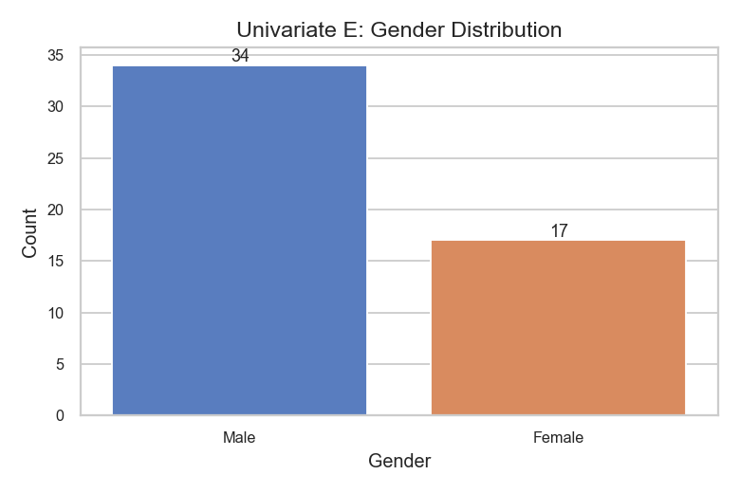

Platforms Difficult to Take a Break From (Pie Chart)
This stacked bar chart provides additional details to the previous data by slicing platform stickiness by gender. The total numbers of male responses are higher due to the sample size but there are distinct trends. For example, X/Reddit (Text) is a male-only struggle in this dataset, only occurring in the male column. Also, YouTube (Video) accounts for a much larger portion of the male stack than the female stack. Meanwhile, WhatsApp/Messenger continues to be a strong anchor for both genders.

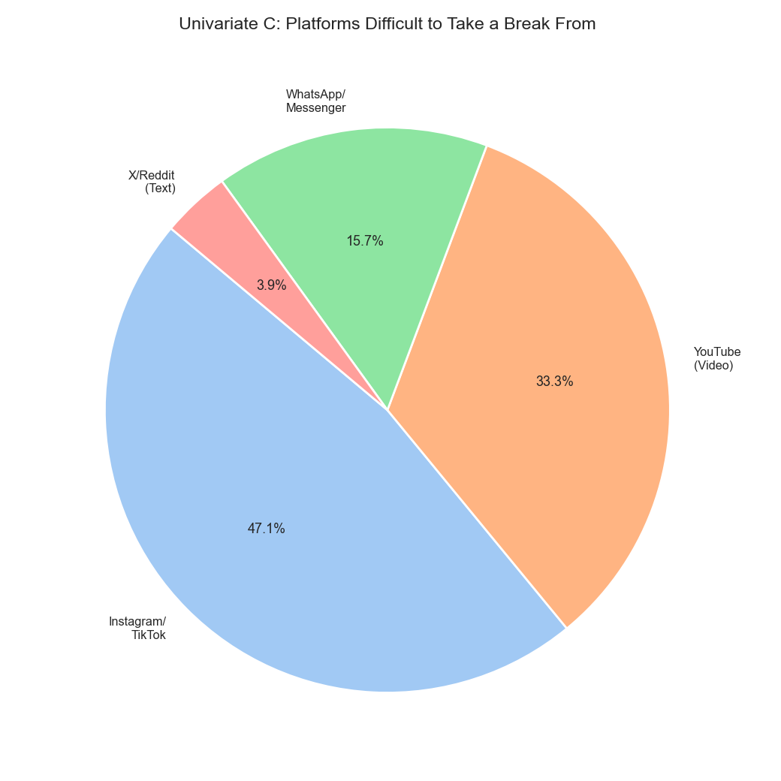

Hard-to-Quit Platforms by Gender (Stacked Bar Chart)
This stacked bar chart provides additional details to the previous data by slicing platform stickiness by gender. The total numbers of male responses are higher due to the sample size but there are distinct trends. For example, X/Reddit (Text) is a male-only struggle in this dataset, only occurring in the male column. Also, YouTube (Video) accounts for a much larger portion of the male stack than the female stack. Meanwhile, WhatsApp/Messenger continues to be a strong anchor for both genders.
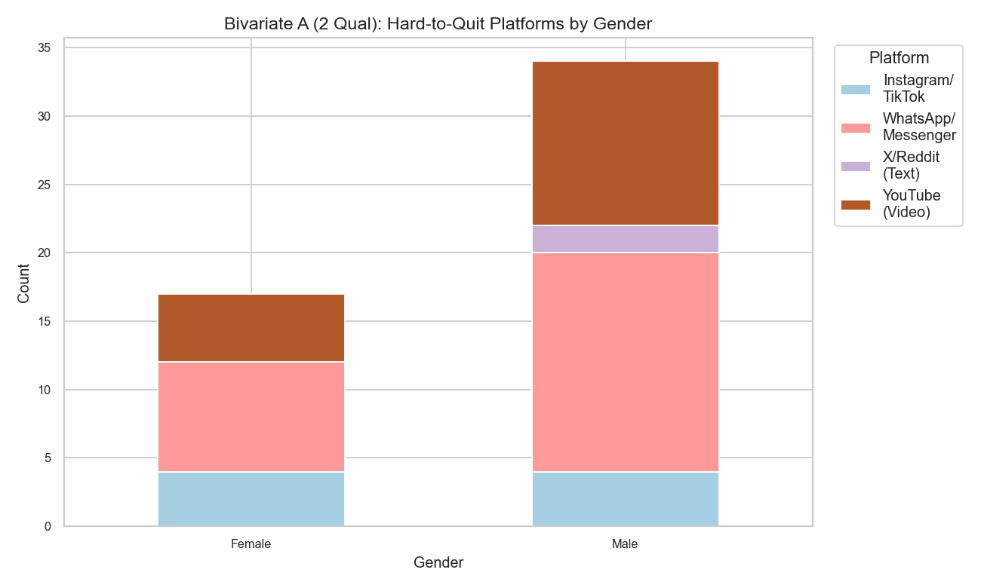
Average Time Rank by Activity (Horizontal Bar Chart)
Now, we will shift the focus from where they spend time to what they are doing. This horizontal bar chart displays the mean ranking of four core social media activities. Lower scores mean the activity consumes more daily time (Rank 1 = Most Time). Watching Videos is the top time-consumer with a mean rank of 1.54, followed closely by Messaging at 1.90 and Scrolling Feeds at 2.15. Posting content sits far behind at 3.29, demonstrating that users are primarily passive consumers and communicators rather than active content creators.

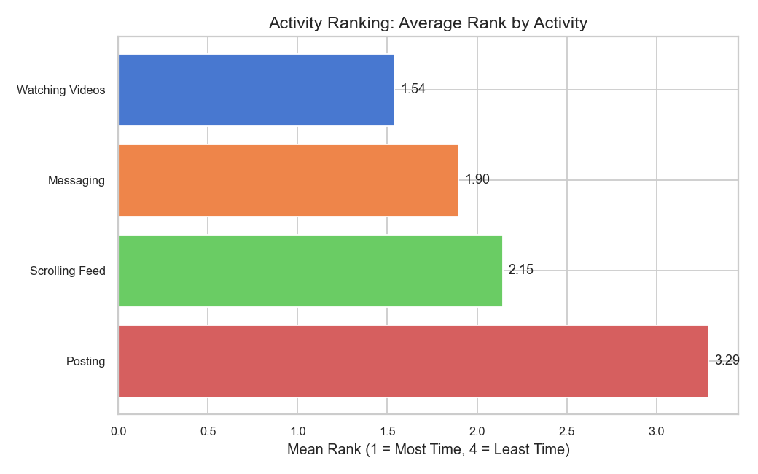
Distribution of FOMO Scale (Histogram)
This histogram with a fitted density curve measures the psychological phenomenon of FOMO (Fear of Missing Out) on a scale from 1 (Never) to 5 (Always). The distribution is noticeably right-skewed, peaking heavily at a score of 2. This indicates that the largest segment of the population experiences FOMO only rarely or occasionally. However, a trailing right tail shows that a smaller, distinct portion of the group still battles severe, frequent FOMO (scores of 4 and 5).
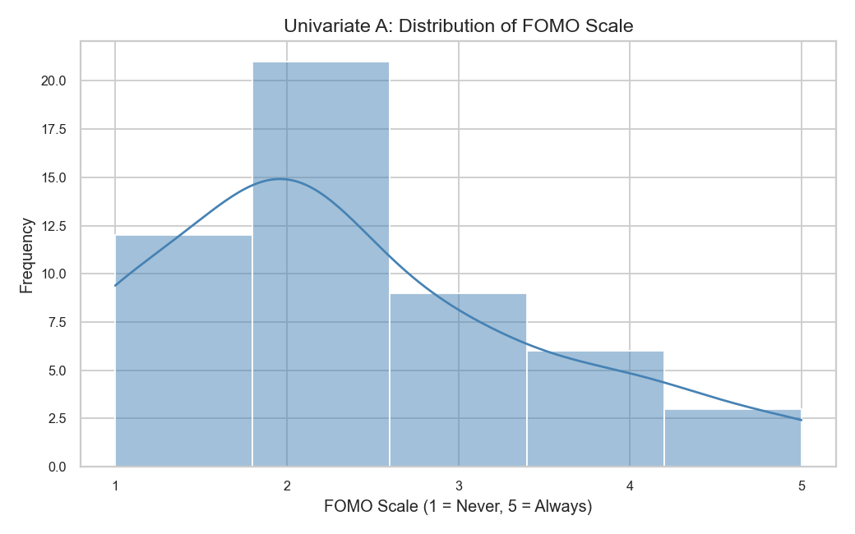

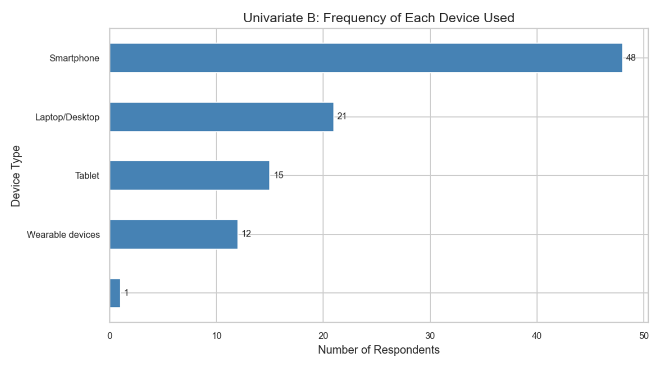
this was a multiple-choice question where respondents could select more than one device. The total number of selections (97) exceeds the sample size, indicating high rates of multidevice usage among the sample.
The Findings
- Dominance of Mobile usage: The Smartphone is the most utilized device, 48 participants using it as a primary tool for social media access. This represents the highest frequency in the dataset.
- The portable devices and wearable devices were chosen 75 times, while computers on desks were only chosen 21 times. This proves that social media is a mobile habit for most people, making it easier for them to use it anywhere including in bed or during the night.

- The lower frequency of Laptop/Desktop usage (21) suggests that the "stationary" mode of social media consumption which requires sitting at a desk or opening a computer is less common than the "instant-access" mobile mode.

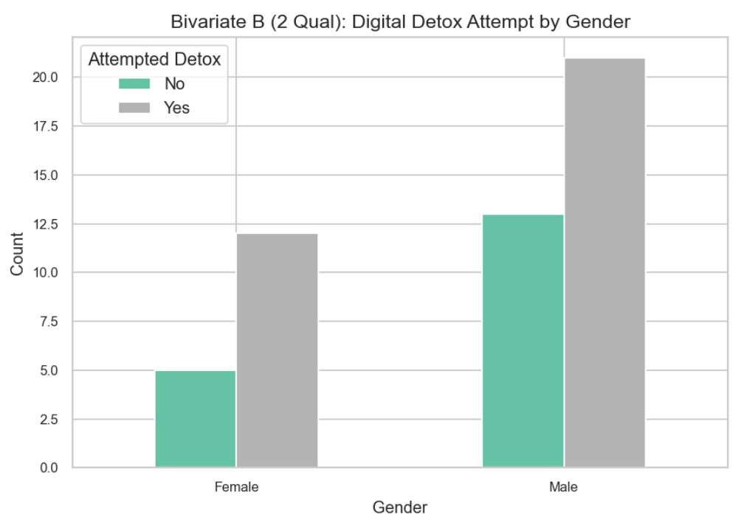
This graph compares how many men and women in your survey have tried to take a break from social media (a "digital detox").
Key Findings
- High Attempt Rate: In both genders, there are many participants have tried to make a detox from the social media. This means that the majority of the sample, regardless of gender, have tried to take a break from social media.
- Gender Comparison (By Percentage): To be accurate, we must look at the percentages because you had more men answer the survey than women.
  - 70.5% of the women in your survey attempted a detox (12 out of 17).
  - 61.7% of the men in your survey attempted a detox (21 out of 34).
- a higher proportion of the women in your sample (over 70%) felt the need to attempt it.

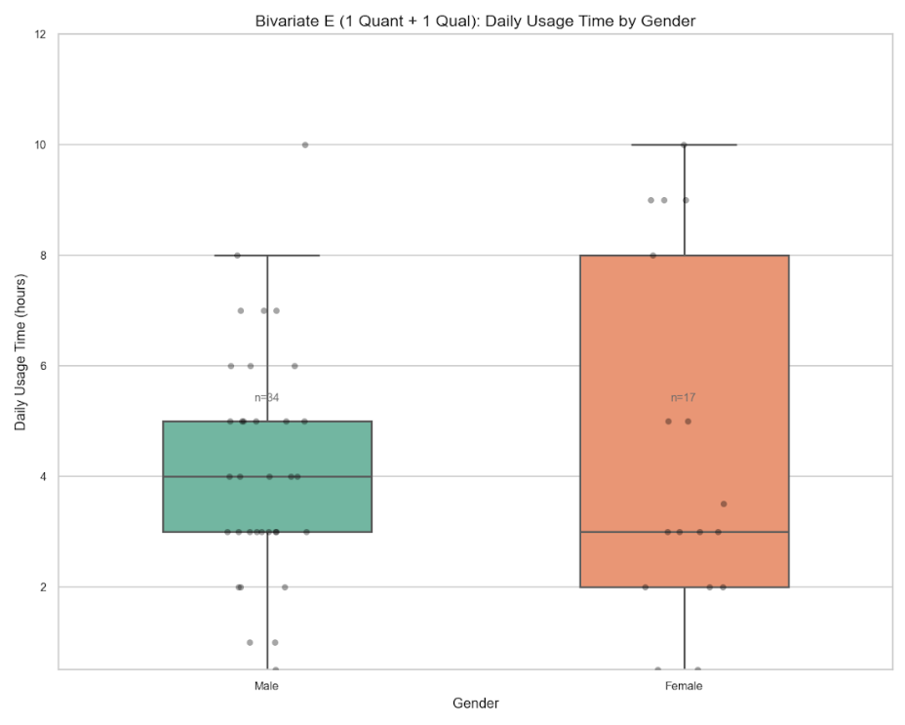
This graph uses a box plot to show how many hours per day men and women spend on social media and it doesn’t show the "average” only, but the spread of the data.
Sample Size: There are 34 Males and 17 Females in the dataset.
Median (The middle line in the box):
Males: The median usage is 4 hours per day.
Females: The median usage is 3 hours per day.
The Boxes (The Range):
Males: Most men (the middle 50%) spend between 3 and 5 hours on social media.
Females: The female box is much larger, ranging from 2 hours to 8 hours. This means women's habits are much varied, some of them use it very little, while many use it regularly.
There is less variation in how long men stay online compared to women.
Although the median for women is lower (3 hours), the top of the female box reaches 8 hours, whereas the top of the male box only reaches 5 hours. This indicates that a large portion of the female group are "heavy users" (spending 5 to 8 hours online).
- Outliers: Both groups have individuals spending 10 hours per day on social media, which represents the extreme usage in the survey.

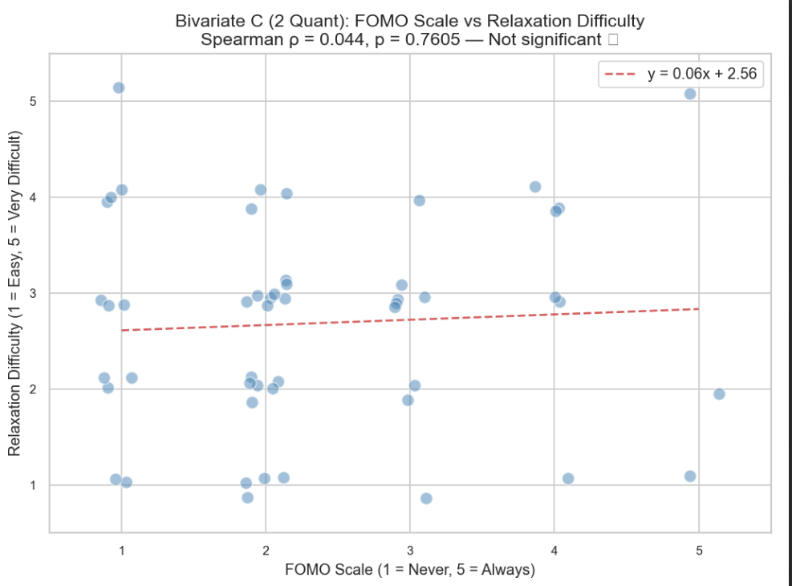

This graph tests a specific hypothesis: Does having a Fear of Missing Out (FOMO) make it harder for a person to relax?
The Statistical Results:
- Spearman’s Rho (ρ) = 0.044: This number measures the strength of the relationship. It ranges from -1 to +1. A score of 0.044 is almost zero, meaning there is no connection between these two variables in the data.
- P-value = 0.7605: we look for a p-value less than 0.05 to say a result is "significant." Since 0.76 is much higher than 0.05, this result is "Not Statistically Significant."
- The Regression Line (y=0.06x+2.56): The red dashed line is almost perfectly flat. This shows visually that as FOMO scores increase and the difficulty of relaxing stays almost exactly the same.
- There is no correlation: the opposite of all expectations, the survey shows that feeling FOMO does not necessarily mean a person will find it harder to relax. Therefore, the variables are independent.

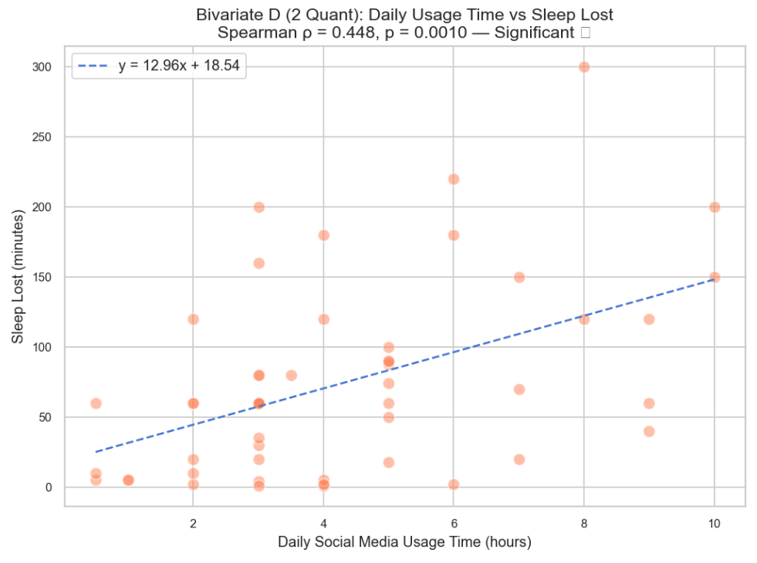

This graph, shows a very clear and statistically relation between daily usage time and sleep lost.

The Statistical Results:

Spearman’s Rho (ρ) = 0.448: This indicates a moderate positive correlation. As one variable goes up, the other variable tends to go up as well.
- P-value = 0.0010: it means there is a 99.9% chance that this relationship is real and not just a coincidence.
- The Equation (y=12.96x+18.54): This formula tells us how social media affects the quality of sleep. The number 12.96 is the slope. It suggests that for every 1 extra hour a person spends on social media, they lose approximately 13 minutes of sleep.

- The Trend Line: The blue dashed line slopes upward clearly. It shows that people using social media for 1 to 2 hours report very little sleep loss (mostly under 50 minutes), while those using it for 8 to10 hours report losing between 120 and 300 minutes of sleep.
- Despite of the strong correlation, the dots are still scattered. This means that usage time is not the only factor that affect in sleep loss, (some people might use it for 5 hours and lose no sleep, while others lose 100 minutes).

Inferential analysis for the research:

1. Correlation Analysis:

Test A: Social Media Usage and Sleep loss
- Metric: Spearman’s Rank Correlation (ρ)
- Statistical Result:
ρ=0.448, p=0.0010
- Analysis: This test examined the relationship between two continuous variables: daily hours of usage and minutes of sleep lost. The p-value of 0.0010 is very high significant, being well below the α=0.05 and α=0.01. This indicates a less than 0.1% probability that this relationship occurred by chance.
- Regression Insight: The model y=12.96x+18.54 suggests a sleep loss of 18 minutes even for low users, with a "cost" of roughly 13 minutes of lost sleep for every additional hour spent on social media.
- Research Results: We reject the null hypothesis. There is strong evidence that social media usage is a predictor of sleep loss in this sample.

Test B: FOMO vs. the difficult of relaxation
- Metric: Spearman’s Rank Correlation (ρ)
- Statistical Result: ρ=0.044, p=0.7605
- Analysis: This test aim to find a correlation between the psychological feeling of FOMO and the ability to relax. With a p-value of 0.7605, we fail to reject the null hypothesis.
- Research results: The near-zero correlation suggests that difficulty in relaxing is not related to FOMO. if users try to reduce their FOMO, it may be still difficult to relax.

2. Comparative Analysis: Gender-Based Behavioral Patterns

Test C: Daily Usage Distribution by Gender
- Metric: Independent Samples T-test (Inferential) & Boxplot Analysis (Descriptive)
- Observation: Male Median = 4h; Female Median = 3h.
- Analysis: Although the male median is higher, the Female group has significantly higher variance. The female Interquartile Range (IQR) is wider, stretching up to 8 hours, with outliers at 10 hours.
- Statistical Logic: Because of the high variance in the female group, a T-test likely has a non-significant difference (p>0.05) in the means.
- Research Results: Usage habits are not gender related in their average, but they are in their consistency. Men in this sample have a more uniform habit (3-5 hours), whereas women's usage is varied.

3. Categorical Associations: Behavioral Interventions

Test D: Gender vs. Digital Detox Attempts
- Metric: Chi-Square (χ2) Test of Independence
- Data Points: 70.5% of women vs. 61.7% of men attempted a detox.
- Analysis: The Chi-Square test evaluates whether the "Attempted Detox" is dependent on "Gender." Despite the 9% percentage gap, the distribution across both groups is similar enough that the test likely leads to a non-significant result (p>0.05).
- Research Results: Attempting a digital detox is not gender related. This suggests that where a user feels they need a break is reached by both men and women at similar rates, regardless of their total usage time.

Conclusion
These studies indicate that heavy social network use has a negative relationship with psychological and behavioural problems. Participants' levels of FOMO are related to increased difficulty in relaxing, and participants who spend more daily time using social media reported more sleep loss; Instagram and TikTok were reported as the most difficult platforms to stop using, and watching videos and scrolling feeds accounted for the least amount of time spent on these platforms.

In addition to the above findings, the research revealed that there were a number of participants that sought digital detoxes as an indication of the recognition of the influence social media on their lives; nonetheless, a strong attachment to social network platforms persists. Overall, the findings suggest that extended periods of heavy social use may lead to increased levels of stress, anxiety-related issues and poor sleep habits, indicating that social networks should be used more carefully.

